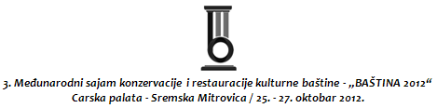

PRIJAVA-UGOVOR ZA IZLAGAČE/APPLICATION-CONTRACT FOR EXHIBITORS

Naziv izlagača/Company name
Država/State
Mesto, ulica i broj/
City, street and number
Osoba za kontakt/Contact Person
Tel./fax. - Phone/Fax
Kontakt email/Contact Email
Delatnost/Activity
PIB
Rok za prijavljivanje/  The deadline for applications | 05.10.2012.

VRSTA IZLOŽBENOG PROSTORA/ TYPE OF EXHIBITION SPACE | NARUČEN/  ORDERED | CENA/  PRICE
Zakup izložbenog prostora bez izrade štanda (plato „Carska palata“)  Rental of exhibition space without making a stand (plateau "Imperial Palace") | m² | 10 €/m²
Zakup uređenog izložbenog prostora (“Carska palata“)  Lease arranged exhibition space ("Imperial Palace") | m² | 25 €/m²

- Štandovi u prostoru „Carska palata“ mogu se naručiti u veličini od: 6, 8, i 10 m²
- Stands in space "Imperial Palace" can be ordered in the size of 6, 8, and 10 m²

OSTALE USLUGE/OTHER SERVICES

Priključak struje/Power supply |  | 20 €
Priključak za internet/Internet connection |  | €

Napomena: Cene su izražene u evrima i bez PDV-a.
Plaćanje se vrši u dinarskoj protivvrednosti po srednjem kursu NBS na dan plaćanja.
Note: All prices are in euros, excluding VAT.
Payments will be made in dinars at the average exchange rate of NBS on the payment date.

Datum /Date: Potpis/Signature:

